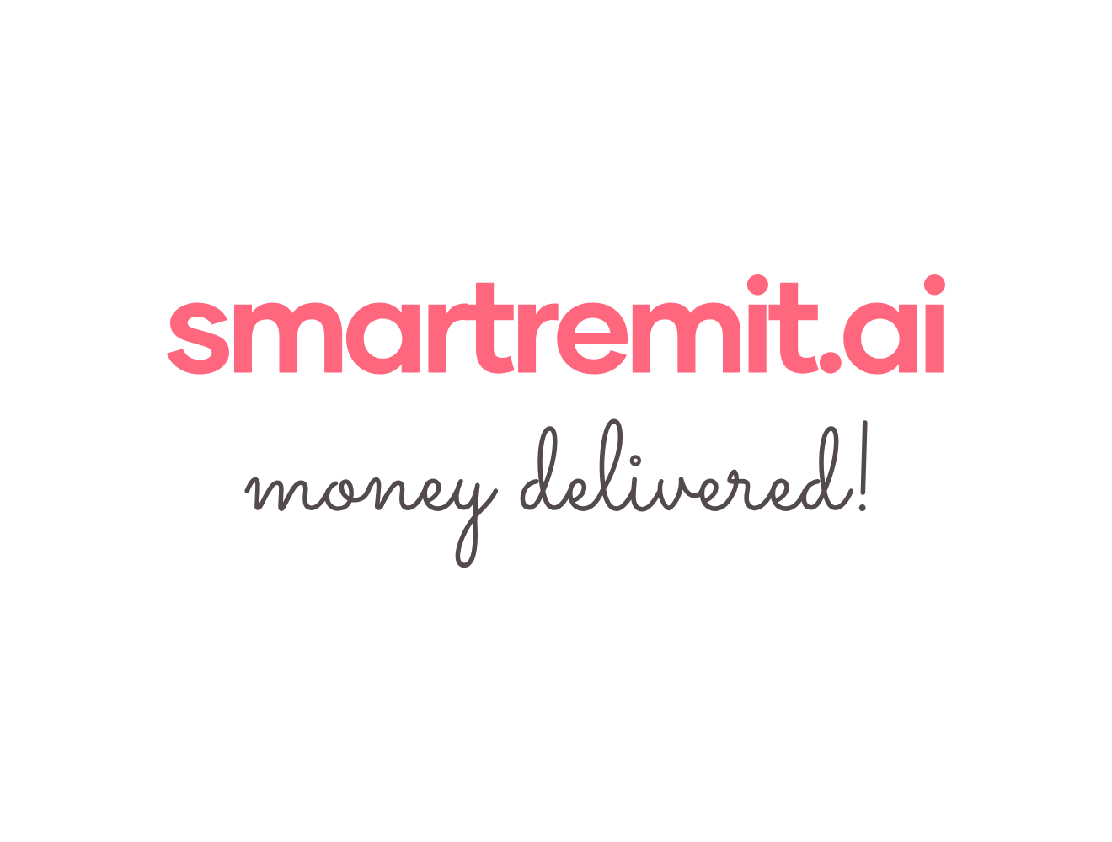SmartRemit AI Test Plan
1. Test Approach
Test Type | What to Check
Functional Testing | Each feature works as expected for normal users.
Negative Testing | The system handles wrong inputs, expired quotes, invalid recipients, and low balance.  Guardrails for non finance queries
Integration Testing | Partner APIs return expected responses in sandbox/staging.
User Acceptance Testing | A small group of users can complete the flow without confusion.
Regression Testing | Existing flows still work after a change is made.
Confirmations | Fund collection, Funds delivery to recipients

2. Test Cases
Test ID | Module | Scenario | Steps | Expected Result | Success/Failed
TC-001 | Onboarding | New user starts registration | Type “I want to send money to India”. | AI starts onboarding and sends a secure KYC link. | -
TC-002 | KYC | KYC link opens | Open KYC link from WhatsApp. | Secure webview opens. No sensitive data is requested in chat. | -
TC-003 | KYC | Valid KYC submission | Submit valid identity details in the test environment. | The user becomes verified based on KYC results. | -
TC-004 | KYC | Invalid KYC submission | Submit invalid or expired ID in test environment. | The user receives a clear retry or support message. | -
TC-005 | Funding | Link bank account | Complete bank linking through sandbox. | The funding source is saved and shown with masked details. | -
TC-006 | Recipient | Add UPI recipient | Send “Add Mom with UPI mom@bank”. | The recipient is saved with a nickname. | -
TC-007 | Recipient | Invalid UPI format | Enter badly formatted UPI ID. | The system rejects it and asks for correction. | -
TC-008 | Recipient | Add bank recipient | Enter name, account number, and IFSC. | The recipient is saved after format validation. | -
TC-009 | Recipient | Invalid IFSC | Enter incorrect IFSC format. | The system shows error and asks for valid IFSC. | -
TC-010 | FX Quote | Generate standard quote | Send “Send $200 to Mom”. | AI shows rate, fee, total cost, and INR payout amount. | -
TC-011 | FX Quote | Quote expires | Wait beyond quote lock time and try to confirm. | The system fetches a fresh quote before proceeding. | -
TC-012 | Payment | Confirm payment | Confirm quote using secure PIN or biometric step. | Transaction moves to processing status. | -
TC-013 | Payment | Insufficient funds | Try sending more than available balance. | AI asks users to change funding sources or lower amounts. | -
TC-014 | Tracking | Track latest transfer | Send “Where is my money?”. | AI shows the latest status and estimates the next step. | -
TC-015 | Status Update | Completion notification | Complete payout in sandbox. | The user receives WhatsApp confirmation. | -
TC-016 | Failure | Incorrect recipient details | Use invalid recipient details in test flow. | The system holds/fails payment and provides a correction/refund option. | -
TC-017 | Compliance | AML review case | Trigger compliance flag in test environment. | Transaction moves to on-hold and the user receives a generic review message. | -
TC-018 | Timeout | Partner timeout | Simulate partner API timeout. | The system checks status again and avoids duplicate transfer. | -
TC-019 | Voice Note | Voice command interpretation | Send a voice note saying “Send $250 to Dad”. | AI converts instruction and asks for confirmation before payment. | Maybe Phase 2?-
TC-020 | Recurring | Schedule monthly transfer | Ask to send monthly payment on a fixed date. | AI captures the schedule and asks for confirmation. | -

3. Defect Reporting
Field | Details Required
Issue Title | Short description of what failed.
Module | Onboarding, KYC, recipient, quote, payment, tracking, partner API, etc.
Steps to Reproduce | Clear steps so another person can repeat the issue.
Expected Result | What should have happened.
Actual Result | What actually happened.
Severity | High, Medium, or Low.

